

**Final Project Report**

**On**

Project Title

(A web application)

**Submitted by:**

Student Name

Student Roll No. (Proper roll no.)

**Supervised By**

Supervisor Name

**Computer Science Department**

**DEDICATION**

Our Parents and Teachers all who’ve given us their support during the development of this project and for giving good ideas to prove ourselves as intellectuals in front of our Respected Teachers.

**ACKNOWLEDGEMENT**

Praise to Allah Almighty, Lord of the world, the Merciful and the Beneficent, who gave me strength, power ,coperative people and knowledge to accomplish this task and fulfill the required functionalities.

This was all not possible without the guidance, continuous appreciation and moral support by “**Dr. Shafiq Hussain”**. He was always there whenever I need him help and ideas.

At last, I would like to acknowledge all of the assistance and contributions of University of Sahiwal for supporting me.

**DECLARATION**

I hereby declare that I have developed this application and accompanied report entirely on the basis of my personal efforts. Not any of the portions of the application work presented has been submitted of any application for any other qualification or degree of this or any other university or institute of learning.

(Student Name)

**CERTIFICATE OF APPROVAL**

It is to certify that the final year project of **BS(CS) “Project Title**(A web application)**”** was developed by **Student Name** under the supervision of “**Supervisor Name**” and that in his opinion, it is in scope, fully adequacy and quality of the degree of Bachelors of Science in Computer Sciences.

**Supervisor External Examiner**

Supervisor Name

Designation

Department of Computer Science

University of Sahiwal

______________________________ ____________________________

**Head of Department**

Dr. Shafiq Hussain

Department of Computer Science

University of Sahiwal

**Abstract**

An effective Police Report System is integral to providing quality Complainant service. It helps to measure Complainant satisfaction and is a useful source of information and feedback for improving services. Often Complainants are the first to identify when things are not working properly.

Table of Contents

1 INTRODUCTION 2

1.1 Introduction 2

1.2 Statement of the Problem 3

1.3 Objectives 3

1.4 Proposed Solution 3

1.5 Motivation 4

1.6 Scope of Proposed Solution 4

1.7 Tools & Techniques 5

1.7.1 Hardware Details 5

1.7.2 Software Details 5

1.8 Existing Applications: 5

1.8.1 PITB 5

1.8.2 Punjab Police: 5

1.9 The Necessity 6

1.9.1Confidentiality 6

1.9.2 Accurate Records 6

1.9.3 Minimum Latency 6

1.9.4 Better Communication 6

2 REQUIREMENT ANALYSIS 8

Requirements Gathering Techniques 8

2.1 Requirement Analysis 8

2.1.1 Functional Requirements 8

2.1.2 Non-Functional Requirements 9

2.2 Application Quality Attribute 9

2.2.1 Availability 9

2.2.2 Maintainability 10

2.2.3 Consistency 10

2.2.4 Portability 10

2.2.5 Database Requirements 10

2.3 Use Cases 10

2.3.1 UC1: Login 10

2.3.2 UC2: Manage Members 13

2.4 Use case Diagrams 16

2.5 The Necessity 17

2.5.1 High Speed Internet Connection 17

2.5.2 Signup 17

3 METHODOLOGY & WORKPLAN 19

3.1 Adopted Methodology 19

3.2 Roles & Responsibilities 20

4 SYSTEM ANALYSIS & DESIGN 22

4.1 Sequence Diagrams 23

4.1.1 Sequence diagram 23

4.2 ER Diagram.....................................,.......................................................24

4.3 Data flow diagram 25

4.3.1 Flow diagram (user panel) 25

4.4 Class Diagram 26

5 SYSTEM IMPLEMENTATION 29

5.1 Introduction 29

5.2 Screenshots 29

6 SYSTEM TESTING 38

6.1 Introduction 38

6.2 Testing Plan 38

6.2.1 Unit Testing 38

6.2.2 System Testing 39

6.2.3 Integration Testing 39

6.2.4 User Acceptance Testing 39

6.3 Test Cases 39

6.4 Testing Results 41

7 CONCLUSION & FUTURE WORK 44

7.1 Conclusion 44

7.2 Future Work 44

REFERENCES: 45

**CHAPTER # 1**

INTRODUCTION

# INTRODUCTION

In this chapter, we will introduce this application, software tools, problem statement,

objectives, scope of this application, proposed application, motivation of this proposed solution, relevance to courses and tools & techniques which are used to implement this application

## Introduction and History:

## An effective Police Report System is integral to providing quality Complainant service. It helps to measure Complainant satisfaction and is a useful source of information and feedback for improving services. Often Complainants are the first to identify when things are not working properly.

The properties of the system are as follow:

1) Smooth flow of data without any hurdles.

2) Adequate validation checks for data entry.

3) Adequate security of data.

4) Facility to update data from time to time.

5) Prompt and specific retrieval of data.

6) Flexibility in the system according to the changing environment.

7) Controlling redundancy in storing the same data multiple times.

8) Accuracy, timeliness and comprehensiveness of the system output.

9) Stability and operability by people of average intelligence.

10) Enhancement in the completion of work within the constraints of time

The scope of the system is quite wide. It can be implemented on a WAP-enabled mobile handset, thus providing the Complainants and the Providers.

**Introduction About Project**

**1.2. Admin Panel**

**1.** Admin Login

Admin can login through login form.

**2.** Category

Admin can manage categories (Add, update, delete)

**3.** Sub Category

Admin can manage Subcategories (Add, update, delete)

**4**.State

Admin can manage states (Add, update, delete)

**5.** Manage Complaints

Access Complaint info, Change Complaint status.

6. Manage the Users

Admin can manage the all the Users Profile. Take a print out of all profiles.

7. User slog

Admin can also view user log info

8. Change Password

Admin Can own password

**1.3User Panel**

1. User Registration

2. User can register through user registration form

3. User Login

4. User can login through login form

5. Forgot Password

6. User can retrieve password through forgot password link

7. User Dashboard

8. User Profile

9. User can manage own profile

10. Lodge Complaint

11. User can Lodge his/her Complaint.

12. Complaint History

13. User can view lodged complaint and status.

14. Change Password

## Statement of the Problem

Public surveys and reports of government accountability and redress institutions show that the police are one of the most widely feared, complained against, and least trusted government institutions in Pakistan, lacking a clear system of accountability and plagued by corruption at the highest levels. District-level police are often under the control of powerful politicians, wealthy landowners, and other influential members of society. There are numerous reported cases of police extra judicial killings of criminal suspects, harassment and extortion of individuals who seek to file criminal cases, especially against members of the security forces.

## Objectives

The **purpose** of the police service is to uphold the law fairly and firmly; to prevent crime; to pursue and bring to justice those who break the law; to protect, help and reassure the community; and to be seen to do this with **integrity**, common sense and sound judgement.

## Proposed Solution

Online police complaint is an integrated solution that enables citizen to track the FIR,view the status online from anywhere using internet.Admin and user also access the system to update and view the status of complaint.

## Motivation

Now a days, online system is the need of hour due to panademic conditions.Every organisation needs an online police complaint system that provides multichannel capabilities, advanced reporting functionalities as well as platform for cross-functional collaboration.

## Scope of Proposed Solution

The modules that are selected to be implemented in this web application (Online Police Complaint system) are the modules that are found as a prior need of citizen. This application can fulfill the requirements of online complaint about crime in society . Using this system we are creating awareness in the citizen of our society.

## Tools & Techniques

Police Complaint System is Web based Project consists of software and hardware tools.

### Hardware Details

* No Hardware Require except laptop/tablet/phones.
* Normal Internet Connection

### Software Details

* My SQL
* Xamp server

## Existing Applications:

### PITB:

The **app**, developed by Punjab Information Technology Board (PITB), is **used** for tracing and recovering stolen and snatched phones. It generates an alert to the **police** control room on a possible sale of a snatched or stolen phone. The **app** will check if an **FIR** is registered against the IMEI number of the phone or not.

### Punjab Police:

One of the initiatives of Punjab Police is the establishment of an integrated IGP Police Complaint Center. Previously the complaints were received through post or a person had to travel to Lahore to submit his complaint in person at the Inspector General of Police office. This initiative aims at receiving complaints through SMS and voice calls on a short code (8787). Moreover, complaints are also received online as well as through emails.

## The Necessity

There are some necessities for this website conduct assistance is as follows:

### Confidentiality

Administrator have full control all over the system and it must be confidential.

### Accurate Records

Police Complaint system must show accurate records.

### Minimum Latency

Police Complaint System support minimum latency.

### Better Communication

Police Complaint system must provide the facility of better communication

using internet connection.

**CHAPTER # 2**

REQUIREMENT ANALYSIS

# 

# REQUIREMENT ANALYSIS

In this chapter requirements analysis is discussed. For developing any project, the major problem is requirement gathering. Asking questions from clients is straight forward than collecting requirements. We will also focus on functional and non-functional requirements.

The procedure for gathering requirements has its own defined procedure according to the complexity of the application. To define project schedule and processing, different models and techniques also focused on this chapter.

## Requirements Gathering Techniques

A requirement can be defined as a condition or capability that must be processed by a product or an application. Techniques that can be used for collecting requirements are as follows:

* By questionnaire and survey
* By interview
* By observations
* Using software tools
* Using techniques for decision making
* Focus on facilitated groups and workshops
* Use of prototype

## Requirement Analysis

Requirements analysis is the process of planning, forecasting and studying the overall former needs of the application requirements. Requirements analysis is further divided into two parts:

1. Functional Requirements
2. Non-Functional Requirements

### Functional Requirements

Functional requirements are the requirements that should be provided by an application. It is defined as a service statement. Functional requirements tell how an application should behave in different situations and how it will react to a particular input. Functional requirements of the police complaint system are as follows: The main functions of our project are following

Functional requirements of the Police Report System are as follows:

REQ-F1: The administrator will be able to manage user’s information.

REQ-F2: The administrator will be able to update/remove the account of the users.

REQ-F3: The project will generate separate services for logins.

REQ-F4: The project will provide facility to donor and receiver communication.

REQ-F5: The project will be managing daily growth of data on the backend.

### Non-Functional Requirements

Non-functional requirements are the constraints or checks on the services and functions provided by an application such as constraints on the development standards/process and constraints of time etc.

Non-Functional requirements of Complaint system are as follows:

* Website shall provide better response and performance. It shall take initial load time depending on internet connection strength.
* Application must be efficient.
* Application must be user interactive.
* Application must be secure by using different standard authentication.

## Application Quality Attribute

### Availability

* Web Application must be responsive and available at every time.
* Availability of high speed internet connection is the major requirement of the application.

### Maintainability

Making changes or upgradeability in the site will not be that much difficult. By having some knowledge of programming, some features of the application might be converted to a new version.

### Consistency

#### When an administrator is updating information consistency must hold there.

### Portability

It is a web application that is why there is no problem in portability process.

### Database Requirements

In this section, the database requirements for this application are mentioned:

We used MY SQL Server for database purpose.

## Use Cases

An important part of the analysis phase is to drawing the diagrams of Use cases. They are used through the phase of analysis of a project to find and divide functionality of the application. Application is separated into actors and use cases.

Actors play the role that is played by the application users. Use cases define the application behavior when one of the actors sends any particular motivation. This type of behavior can be described by text. It describes the motivation nature that activates use case, the inputs and outputs to some other actors and the behavior of conversion of inputs to the outputs. Usually the use case describes everything that can go wrong during the detailed behavior and what will be helpful action taken by the application.

Some of the use cases are as follows:

Some of the use cases are as follows:

### UC1: Login

**Actor:** User

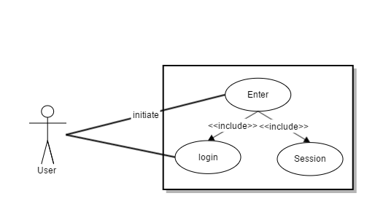

Figure 2.1: Login (use case)

**Pre-Condition:**

1. For the member, he/she must have registered already in application by the administrator.
2. User must enter correct Email address and password for login.

**Post-Condition:**

User can access to application’s main features.

**Basic Path:**

1. Enter Email-Address and password for login.
2. The application verifies the correct format and valid email address and Password.
3. If provided inputs are correct, the application displays the all other user’s content of the application and session of particular user started.

**Constraints:**

1. If provided email address and password are incorrect or invalid, application redirect to main page of user login and show us a message that password is incorrect.

**Non-Functional Requirements:**

1. Short Response Time
2. Better performance
3. Availability

### UC2: Manage Members

**Actor:** Administrator

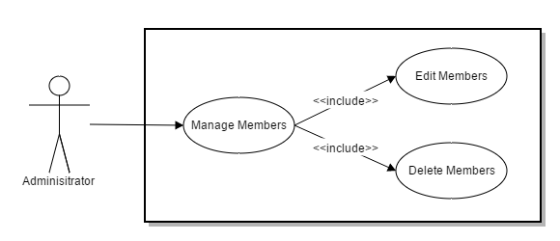

Figure 2.3: Manage Members (Use Case)

**Pre-Condition:**

* + - 1. UC1
      2. The member’s detail is required.

**Post-Condition:**

1. The member information should be edited and deleted.

**Basic Path:**

1. The administrator view the member’s detail and then select a particular member to perform these activities.
2. Update information of specific member by entering updated information and click on update button.
3. The application verifies the valid entered inputs and updated.
4. For deleting information of specific member, applications display the message of confirmation.
5. Administrator clicks on delete button for deleting that member.
6. The application commits changes to the database.

**Non-Functional Requirements:**

1. Better response
2. Easy to use
3. Secure
4. Availability
5. Short response time.

### UC4: Change Password

**Actor:** User

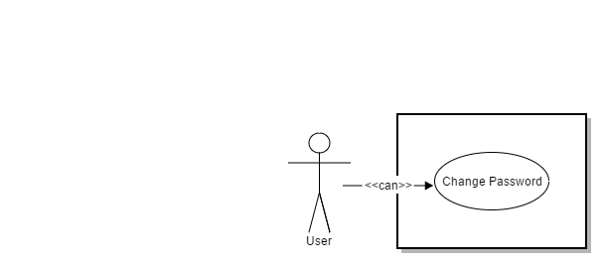

Figure 2.4: Change Password (Use Case)

**Pre-Condition:**

* + - 1. UC1

**Post-Condition:**

Password must be updated into the database.

User can view new password in a text field.

**Basic Path:**

* + - 1. User select change password menu from sidebar menu list.
      2. User enters new password to update old password.
      3. The application verifies and updated into database.
      4. Click on **Logout** to check whether the password has changed or not.

**CONSTRAINTS:**

1. User must enter valid inputs for password.

**NON-FUNCTIONAL REQUIREMENTS:**

* + - 1. Short response time.
      2. Efficient
      3. Availability
      4. Secure

## Use cases

**2.4.1 User Use Case Diagram**

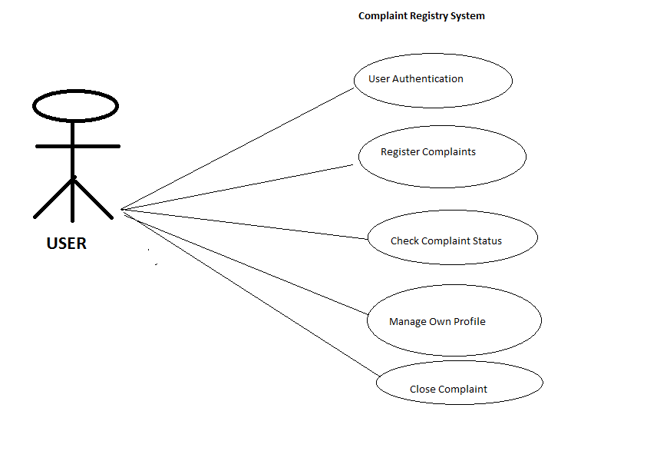

## The Necessity

There are some necessities for this online web application to run properly are as follows:

### High Speed Internet Connection

Online complaint system requires high speed internet connection to run properly.

### Signup

The admin must be signup with application before using application portal.

**2.4.2 Admin UseCase Diagram**

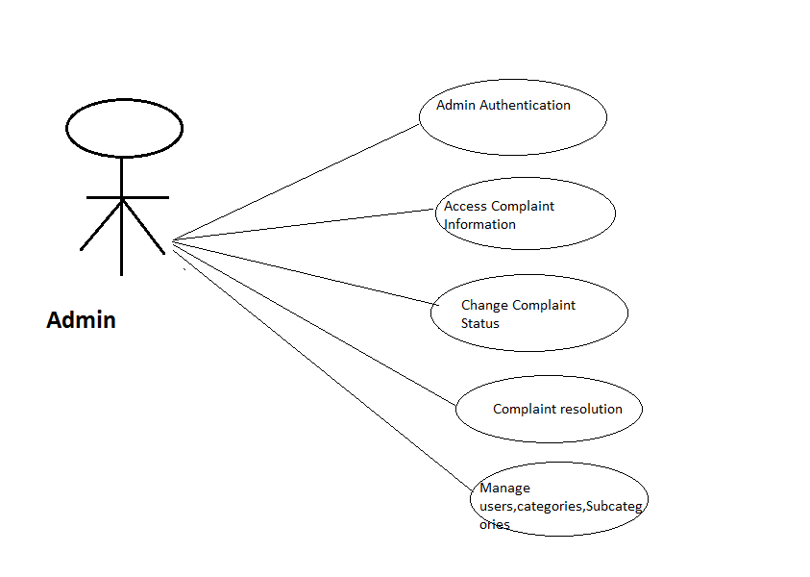

**CHAPTER # 3**

METHODODLOY AND WORKPLAN

# METHODOLOGY & WORKPLAN

In this chapter, we will discuss that what are the existing methodologies and which one we have chosen for implementation of this project in an effective way, also we will discuss advantages of adopted methodology.

What is methodology and why we need it?

Whenever a small or large project has started to develop, first thing all of programmers required is methodology. Methodology is a way of developing a project, in which all of the programmers gather the user’s requirements, design the project, implement it, and after all this testing and maintenance of the project, in a satisfaction of user and according to the project requirements.

**Existing Methodology**

There are several existing methodologies that can be used to develop this application using software development processes.

1- Waterfall Model.

2-Incremental Model.

3-Spiral Model.

4-Agile Model

## Adopted Methodology

I have chosen Waterfall model In the software development process, the very first model that is published from other engineering processes that is cascaded from one phase to another is known as Waterfall model. This model is also known as linear sequential model. In the waterfall model.

Delivered Reason behind using this model is:

1-Firstly all of the requirements gathered

2-After gathering all of the requirements and analysis of all the requirements further move to next phase that is making the design of a project and then implementation, testing and maintenance.

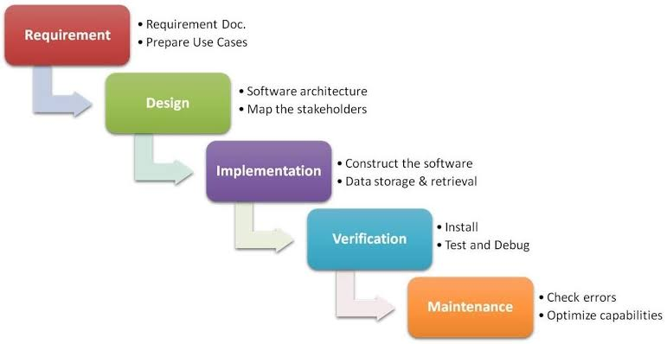

## Roles & Responsibilities

In order to accomplish a goal, documentation and development is done by me.

**CHAPTER#4**

SYSTEM ANALYSIS & DESIGN

# SYSTEM ANALYSIS & DESIGN

In this chapter requirements analysis, feasibility study, planning, forecasting, modeling, scheduling and design of the project is discussed.

The procedure for gathering requirements has its own defined procedure according to the complexity of the application.

## Sequence Diagrams

Sequence diagram uses concept of a Message-Sequence-Chart. It shows interactions of objects in a sequence of time. It shows the classes and objects involved in the scenario and the message sequence between the objects which is desired to carry out the functionality of a given scenario. Sequence diagrams are usually related with the understanding of use case in the logical View of the system which is under development. “Sequence diagrams are sometimes called event diagrams, timing diagrams, event scenarios”.

A parallel vertical line on sequence diagram is called lifeline. Different objects or processes that live simultaneously, and, on horizontal arrows, the messages exchanged, in the order in which processes occur. This allows some specification of some simple runtime scenarios in a graphical pattern.

Police Complaint System

Applicant

Admin

### Sequence diagram

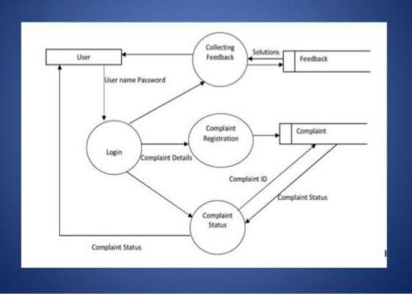

## Data flow diagram

A data flow diagram (DFD) is a graphical representation of the "flow" of data through an [information system](https://en.wikipedia.org/wiki/Information_system), modeling its process aspects. A DFD is often used as a preliminary step to create an overview of the system without going into great detail, which can later be elaborated. DFDs can also be used for the [visualization](https://en.wikipedia.org/wiki/Data_visualization) of [data](https://en.wikipedia.org/wiki/Data_processing" \o "Data processing)

[processing](https://en.wikipedia.org/wiki/Data_processing" \o "Data processing)

### Flow diagram

Police report system

Applicant

Admin

**ER Diagram**

An entity-relationship diagram (ERD) is a data modeling technique that graphically illustrates an information system's entities and the relationships between those entities. An ERD is a conceptual and representational model of data used to represent the entity framework infrastructure.

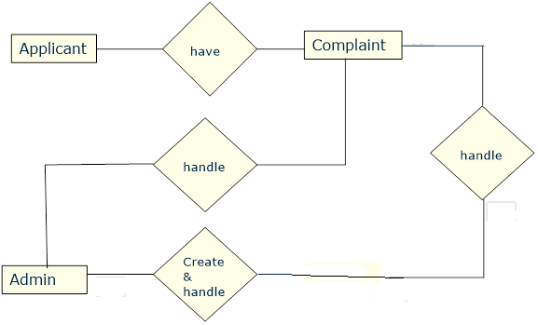

## Class Diagram

The class diagram is the main building block of object direct modeling. It is used both for general conceptual modeling of the systematic of an application, and for detailed modeling translating the models into programming. Class diagrams can also be used for datamodeling.

The classes in a class diagram represent both the main objects and or interactions in the application and the objects. In the class diagram these classes are represented with boxes which contain three parts

* The upper part of holds the name of the class
* Next one holds the parameters of the class

Last one holds the methods of the class

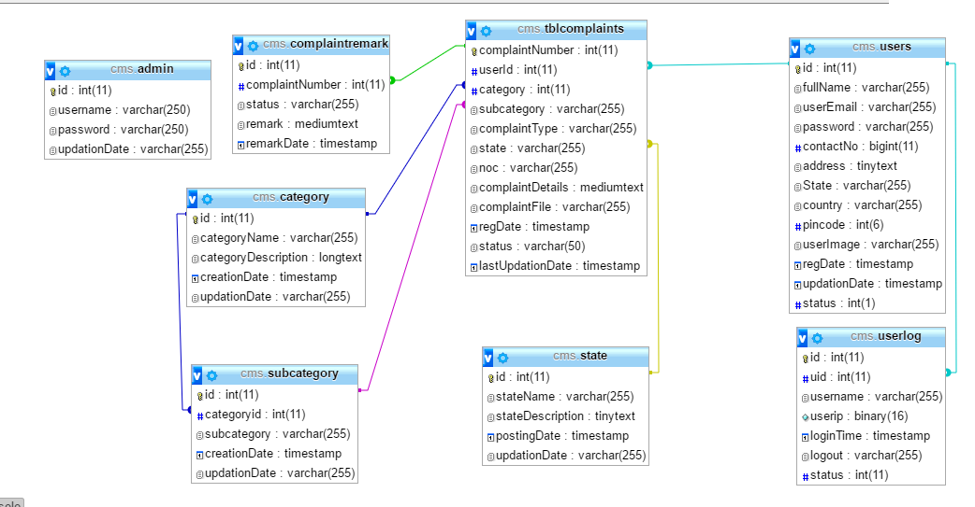

t.”

**CHAPTER#5**

# SYSTEM IMPLEMENTATION

# 

# SYSTEM IMPLEMENTATION

In this chapter, we’ll focus on an implementation of “Online Police Complaint System” application. Where administrator and user can perform many activities on web application.

## Introduction

The most important goal of this phase is to develop the application. The work in this phase should be much more straightforward as a result of the work done in the planning and design phases. This phase involves changing design specifications into executable programs.  When the design is there, developers can have an idea on looks of application. All that is needed by developers is to put them at one place to understand about the intended project.

## Screenshots

**User Registration**

This is sign up page for making an account. User gives information about him like name, email, and password and creates an account.

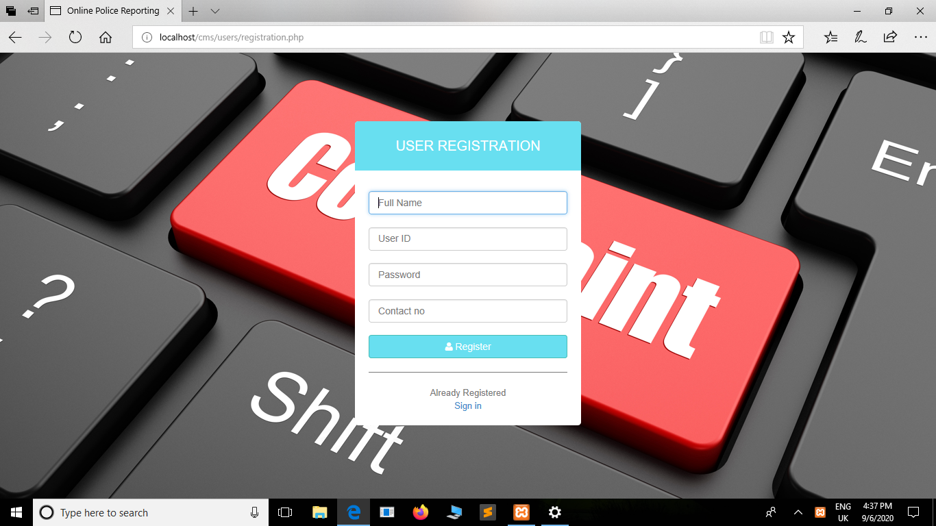

**User Log In page**

This the login page of the users. User need to enter correct username and password for login.

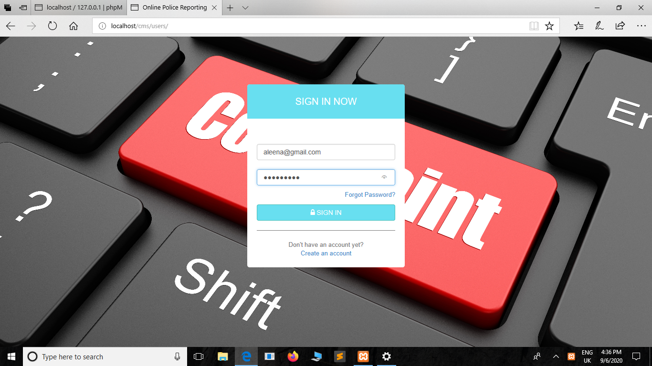

**User. 1-(Dashboard)**

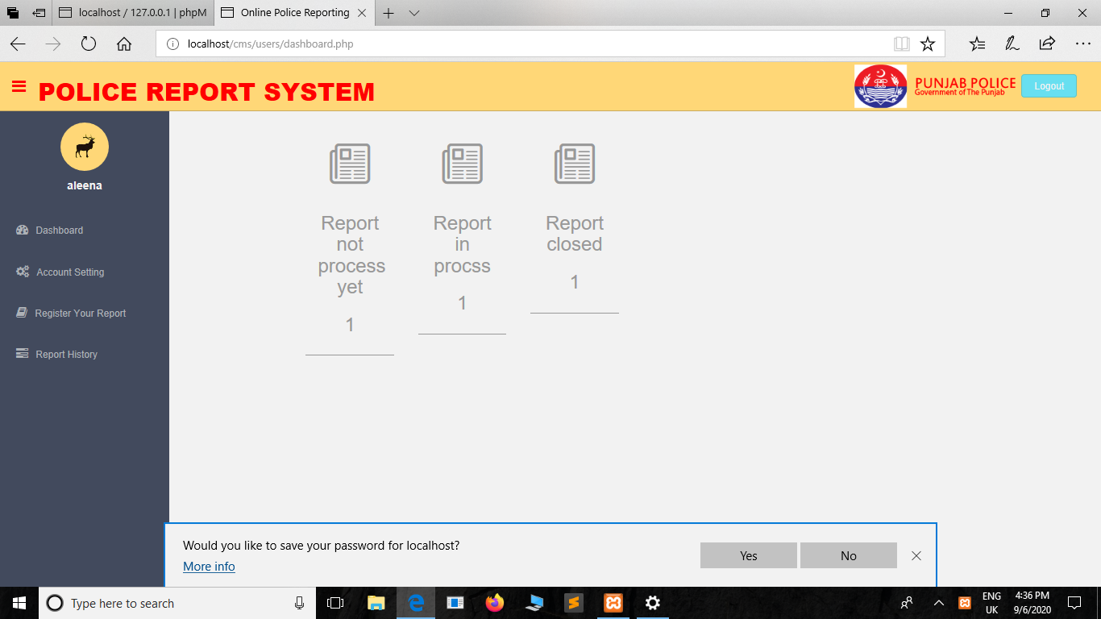

2-Account setting

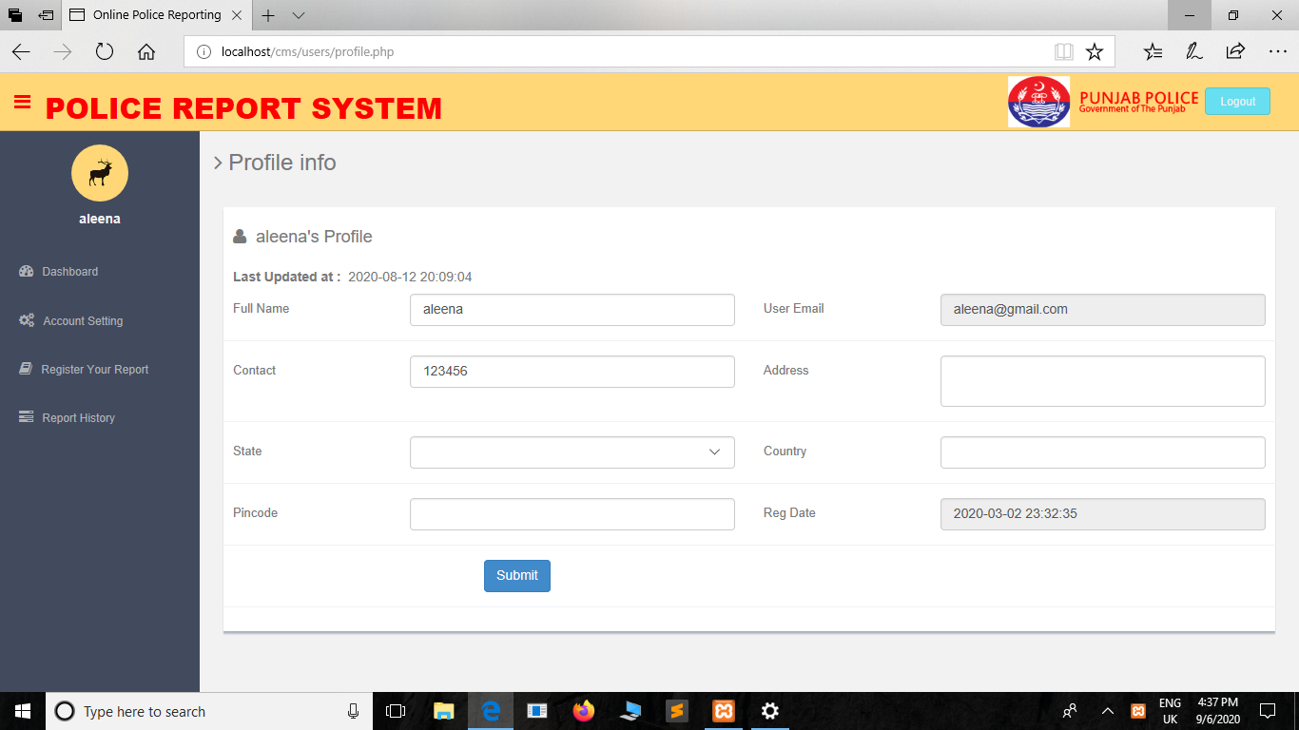

Change Password

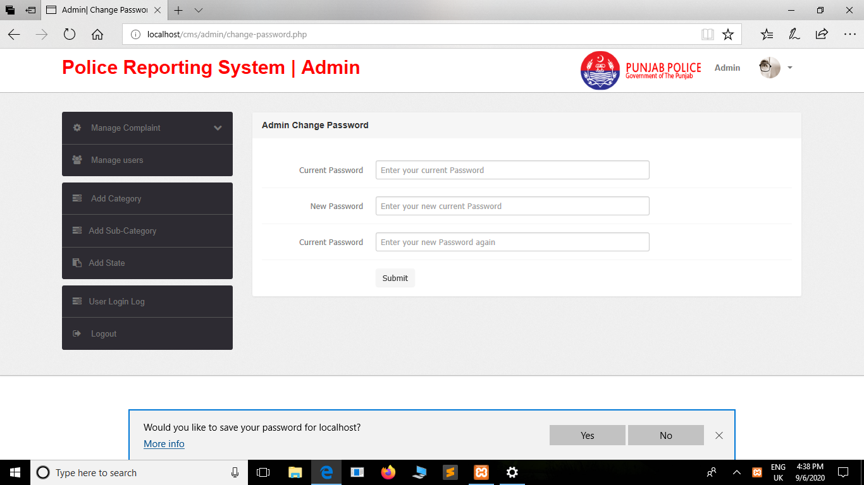

**Admin** **Panel:**

**Manage users:**

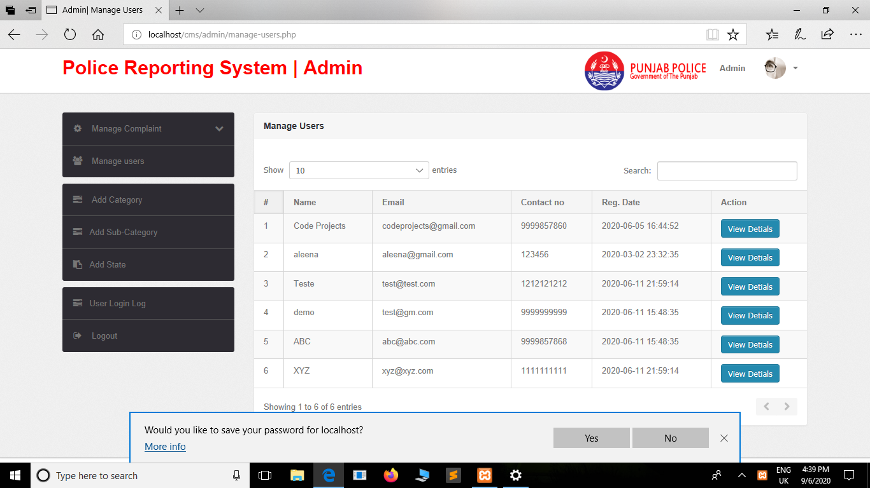

Add Category:

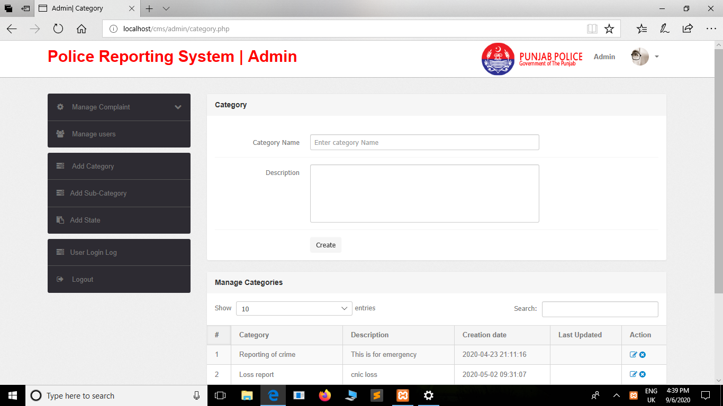

**Add Subcategory**

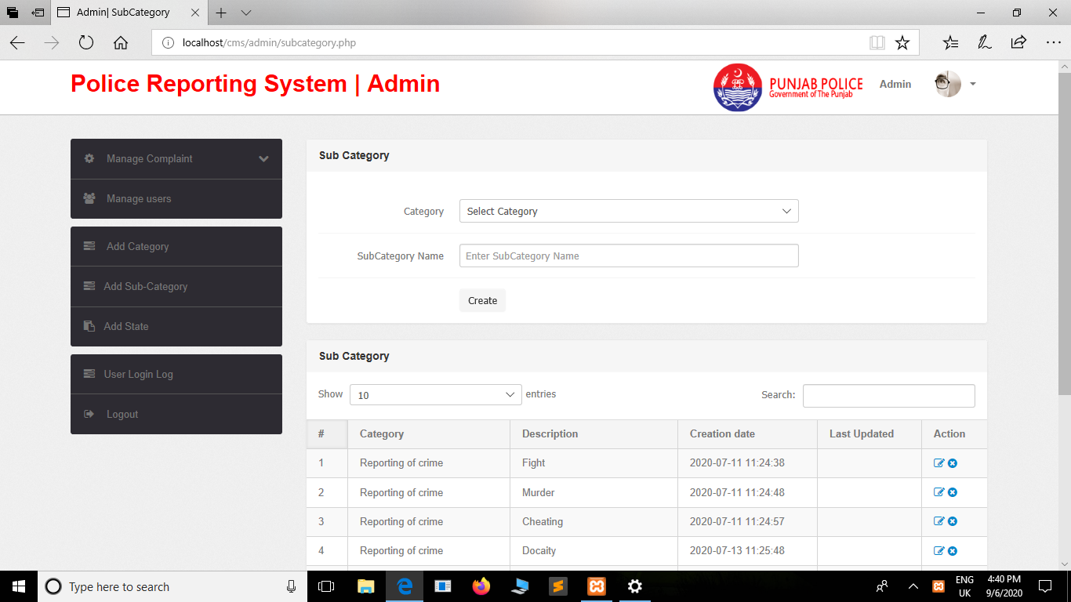

Add state

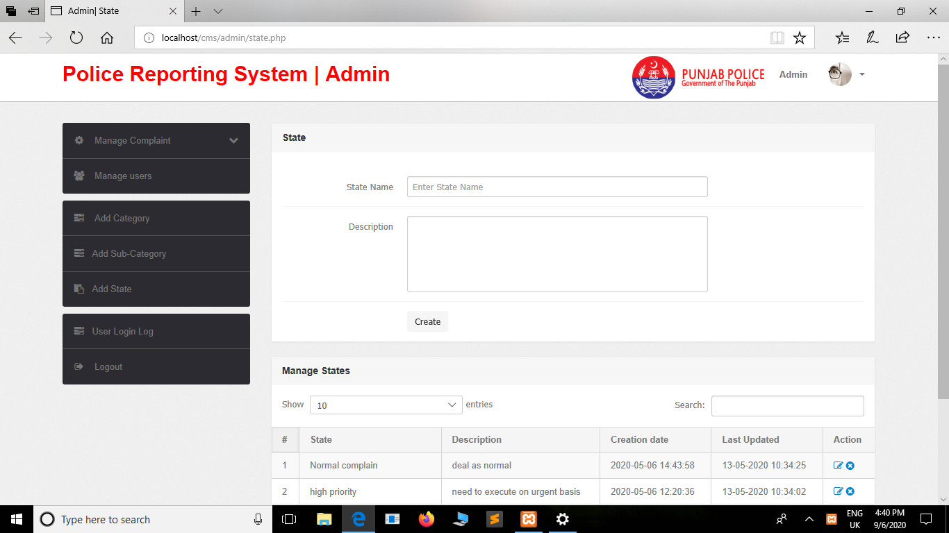

**User Login**

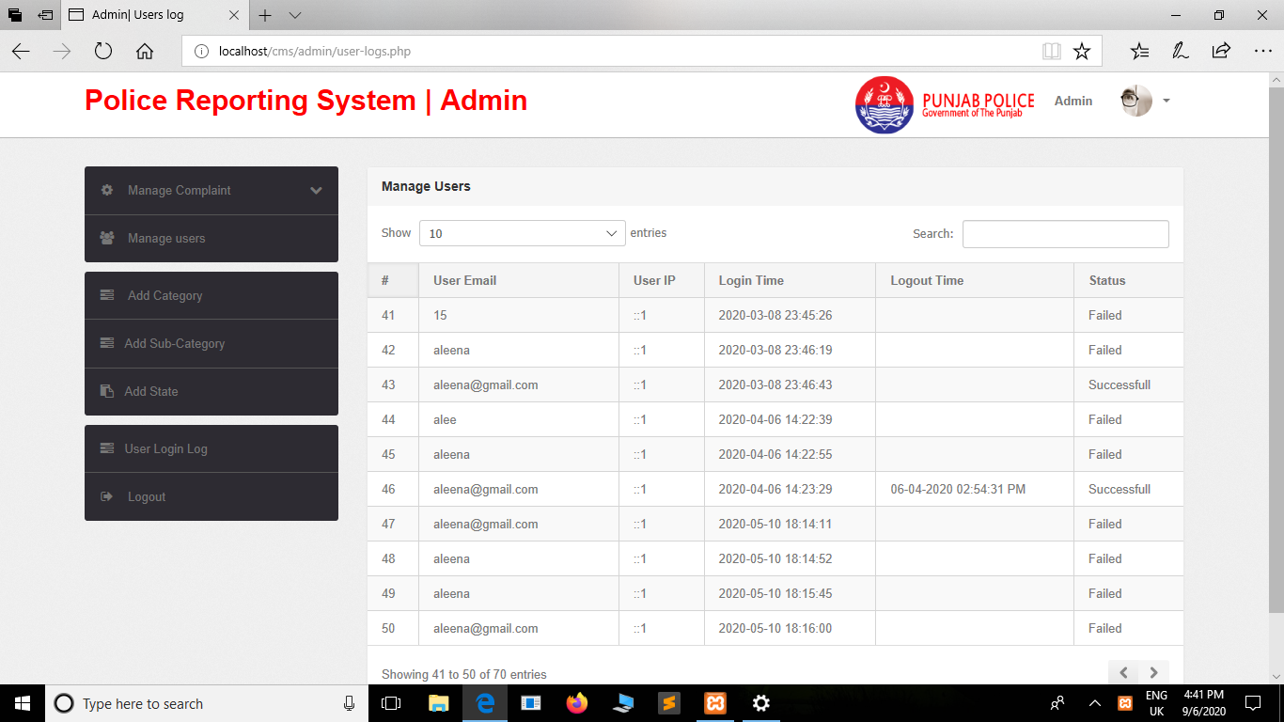

**CHAPTER#6**

SYSTEM TESTING

# SYSTEM TESTING

In this chapter, we will discuss the testing phase of developed application **“Online complaint System”** in different manner to know that how much efficient and effective application is?

## Introduction

A process of performing as application or program with the intention of finding errors and whether the application is fulfilling user needs. It can also be defined as the ability of a program in meeting the required or desired results.

In many methodologies of software engineering, a separate phase is called phase of testing which is performed after the completion of the implementation. There is a benefit in using this approach that it is hard to see one's own mistakes, and a fresh eye can find observable errors much faster than the person who has read the material many times.

## Testing Plan

A process of performing as application or program with the intention of finding errors and whether the application is fulfilling user needs.

### Unit Testing

The software units in an application are modules and routines that are assembled and integrated to perform a specific function. Unit testing focuses first on modules, independently of one another, to locate errors. This enables, to detect errors in coding and logic that are contained within each module. This testing includes entering data and ascertaining if the value matches to the type and size supported by php. The various controls are tested to ensure that each performs its action as required.

Commonly used method is White-Box Testing method. Every time a component of the program is changed, it can be run for testing that is the biggest and famous benefit of this testing phase. Issues that are arise during this phase, allowing to be resolved as quickly as possible. Unit testing is familiar by software developers. It allows them to test their application units before move them to testers for formal testing.

### System Testing

To test the complete application as a whole, system testing has been used. It is beneficial to check whether the application meets its requirements and fulfill Quality Standards.

### Integration Testing

Integration testing allows the software developers to integrate all of the components/ units of the application within a program and then test them in a group. Basically, this testing level is used to catch the defects in the user interface between the functions/ modules. It is useful to determine how logically and efficiently all the units/ components are running together.

Here the streaming module and encoding module options are integrated and tested. This testing provides the assurance that the application is well integrated functional unit with smooth transition of data.

### User Acceptance Testing

User acceptance of an application is the key factor for the success of any application. The application under consideration is tested for user acceptance by constantly keeping in touch with the application users at time of developing and making changes whenever required.

## Test Cases

|  |  |
| --- | --- |
| **Test Cases** | **Objectives** |
| 1 | To make sure that user can easily understand and can use the application |
| 2 | Make sure that user can easily login |
| 3 | Make sure that administrator can easily update, delete anything. |
| 4 | Make sure that admin can view detail of users. |
| 5 | Make sure that user can easily view status of complaints |
| 6 | Make sure that user can lodge complaint easily |
| 7 | Make sure that the application run at cross-platforms successfully. |

## 

## Testing Results

**Table 6‑2: Testing Result**

|  |  |  |
| --- | --- | --- |
| **CRITERIA** | **Test Status** | **REMARKS** |
| All the graphical user interface options display successfully. | Test successful | None |
| Enter valid login user email address and password and then press login | Test successful | None |
| Add, delete, update and view admin using database | Test successful | None |
| Admin view detail of users. | Test successful | None |

**CHAPTER # 7**

# CONCLUSION & FUTURE WORK

# CONCLUSION & FUTURE WORK

In this chapter, we will discuss the results and discussions of this framework “Online Police Complaint System**”** with conclude remarks and will also discuss related future work of this application.

## Conclusion

The System has the benefits of access because it is be developed as a platform independent web application so the admin can maintain a proper contact with the users which may be access anywhere.

This application provide such environment that is more efficient . It will improve the performance of such organizations . It is professionally beneficial.

## Future Work

In next our first preference is to enhance this application by providing more new features that are as follows:

* Instant case assignment
* Notifications when a task is coming due
* Case prioritization
* Role-defined levels of access to protect sensitive data
* All complaint information and associated documents in case file
* Provide location of all police stations nearest to user’s location
* Complaint send directly to officer using same system.

# REFERENCES:

www.w3schools.com

*in.****php****.net*

*en.wikipedia.org/wiki/****PHP***

www.hotscripts.com/category/**php**/

www.**apache**.org/

www.**mysql**.com/click.php